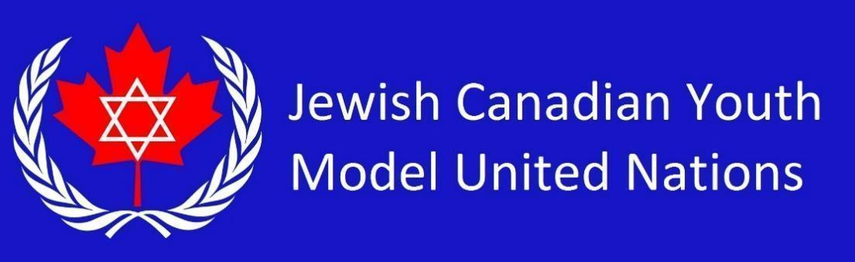

**WTO Country List 2025** *(12 students)*

Federative Republic of Brazil

Republic of Chile

People’s Republic of China

French Republic

Japan

Kingdom of the Netherlands

Republic of Nigeria

Russian Federation

Kingdom of Saudi Arabia

United Kingdom of Great Britain and Northern Ireland

United States of America

Republic of Costa Rica