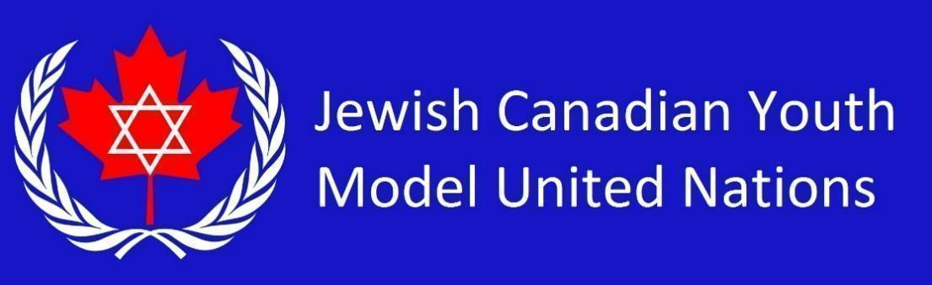

**FAO Country List 2025** *(17 students)*

Republic of Haiti

French Republic

Italian Republic

Republic of India

Federative Republic of Brazil

Republic of Indonesia

Russian Federation

Republic of Yemen

Federal Republic of Somalia

Federal Democratic Republic of Ethiopia

Federal Republic of Germany

Dominion of Canada

Republic of South Africa

New Zealand

Ukraine

Argentine Republic

Arab Republic of Egypt