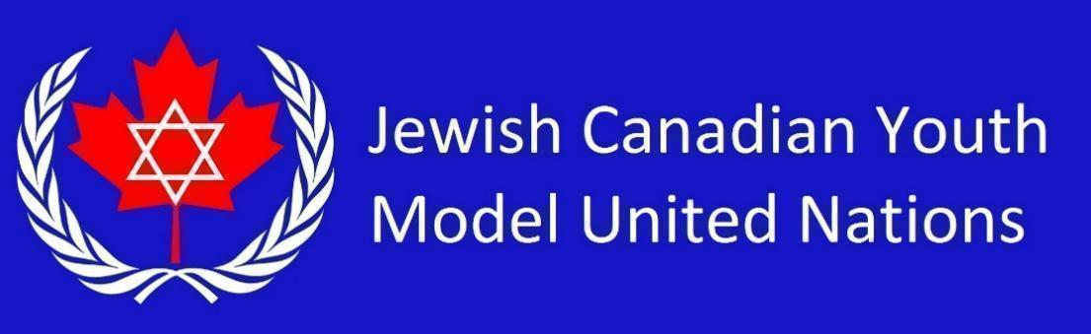

**UNICEF Country List 2025** *(35 students)*

Republic of South Africa

People's Republic of Bangladesh

Islamic Emirate of Afghanistan

Federal Republic of Somalia

United States of America

Hashemite Kingdom of Jordan

Russian Federation

The Kingdom of Saudi Arabia

United Kingdom and Northern Ireland

People's Republic of China

Islamic Republic of Pakistan

Lao People's Democratic Republic

Republic of Sudan

Federal Republic of Germany

Kingdom of Sweden

Japan

Republic of Colombia

Republic of Ecuador

Republic of India

Federative Republic of Brazil

Federal Republic of Nigeria

Kingdom of Thailand

Syrian Arab Republic

Republic of Yemen

Republic of South Sudan

Democratic Republic of the Congo

Ukraine

Republic of Uganda

United Mexican States

Republic of the Philippines

Democratic People's Republic of Korea

Republic of the Union of Myanmar

Bolivarian Republic of Venezuela

Swiss Confederation

Dominion of Canada