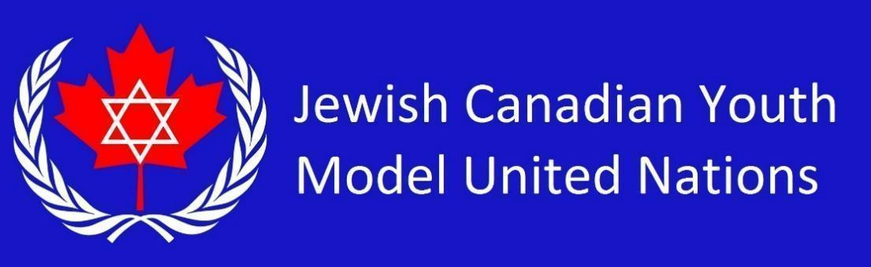

**UNSC Country List 2025** *(15 students)*

French Republic

United Kingdom of Great Britain and Northern Ireland

Russian Federation

United States of America

People's Republic of China

People's Democratic Republic of Algeria

Republic of Ecuador

Co-operative Republic of Guyana

The Swiss Confederation

Japan

Republic of Malta

Republic of Mozambique

Republic of Korea

Republic of Sierra Leone

Republic of Slovenia