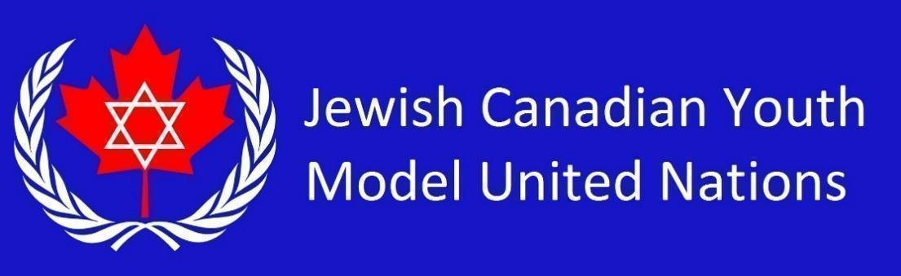

**AU Country List 2025** *(34 students)*

Kingdom of Morocco

Republic of the Sudan

Tunisian Republic

United Republic of Tanzania

The Republic of Kenya

Republic of South Africa

The Republic of Ghana

Federal Democratic Republic of Ethiopia

Republic of Senegal

Federal Republic of Nigeria

Republic of Chad

Republic of Rwanda

Federal Republic of Somalia

Republic of Uganda

Republic of Madagascar

Republic of Sierra Leone

Republic of Guinea

Arab Republic of Egypt

People's Republic of Burkina Faso

Democratic Republic of Congo

Republic of Mali

Republic of South Sudan

Kingdom of Lesotho

State of Libya

Republic of Niger

Republic of Cameroon

Republic of Zambia

Republic of Zimbabwe

Togolese Republic

Republic of Seychelles

Republic of Angola

Republic of Botswana

Republic of Burundi

Republic of Cabo Verde