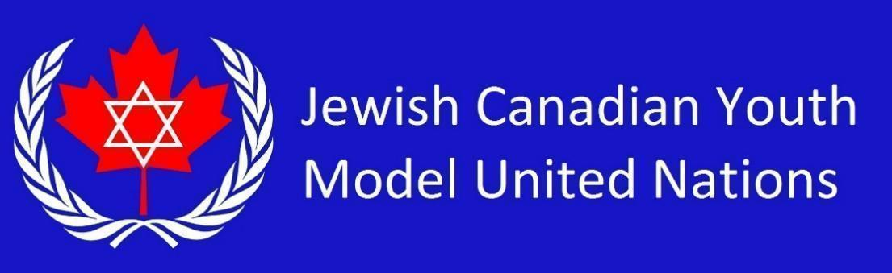

**WHO Country List 2025** *(16 students)*

Republic of South Sudan

Federal Democratic Republic of Ethiopia

United Kingdom of Great Britain and Northern Ireland

United States of America

Dominion of Canada

Republic of Singapore

People's Republic of China

Republic of India

Russian Federation

Federative Republic of Brazil

Republic of South Africa

Democratic Republic of the Congo

Republic of Korea

State of Israel

United Arab Emirates

Federal Republic of Nigeria