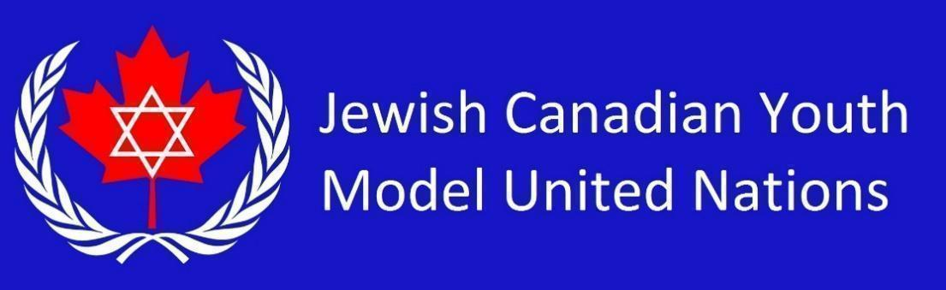

**UNCTC Country List 2025** *(17 students)*

Republic of Cuba

Republic of Ireland

United States of America

Islamic Republic of Afghanistan

Russian Federation

People's Republic of China

Republic of Iraq

The Czech Republic

Republic of Korea

Republic of India

Malaysia

Republic of Rwanda

Republic of South Sudan

Islamic Republic of Iran

United Arab Emirates

Federal Republic of Germany

Dominion of Canada

Republic of Poland

French Republic

Islamic Republic of Pakistan