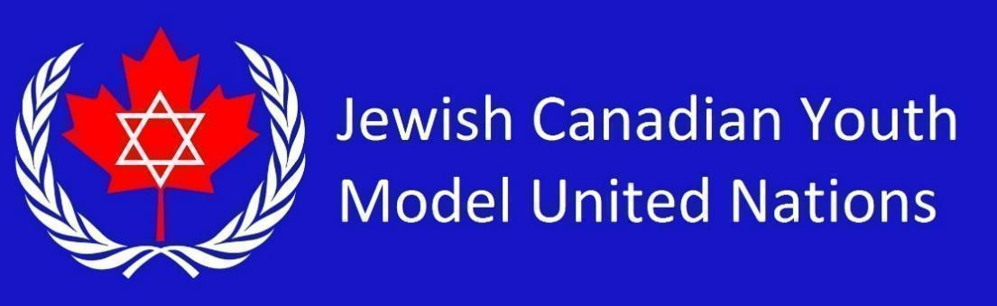

**UNESCO Country List 2025** *(50 students)*

Republic of Bulgaria

Japan

Republic of Angola

People’s Republic of China

Republic of India

Republic of Rwanda

Dominion of Canada

The People's Republic of Bangladesh

United States of America

Italian Republic

Portuguese Republic

Republic of Indonesia

Federal Republic of Nigeria

Republic of Korea

Arab Republic of Egypt

Federative Republic of Brazil

Argentine Republic

New Zealand

Russian Federation

Kingdom of Sweden

Republic of Panama

Federal Democratic Republic of Ethiopia

Republic of South Africa

Islamic Republic of Pakistan

Republic of the Philippines

Republic of Kenya

Republic of Uganda

State of Israel

Republic of Uzbekistan

Democratic People's Republic of Korea

Malaysia

Kingdom of Thailand

Republic of Singapore

Socialist Republic of Vietnam

Islamic Republic of Iran

Republic of Yemen

Republic of Peru

Republic of Zimbabwe

Republic of Haiti

Republic of the Union of Myanmar

Kingdom of Saudi Arabia

Republic of Chile

United Republic of Tanzania

Republic of Colombia

Kingdom of Morocco

Republic of Finland

Republic of Ghana

Swiss Confederation (Switzerland)

Kingdom of Lesotho

Republic of Senegal